1. Soil C pool data was calculated from bulk density and soil C%.

The paper does not report carbon density directly. We calculated carbon density from Table 1, which reported bulk density and percent organic carbon, but not carbon pool.

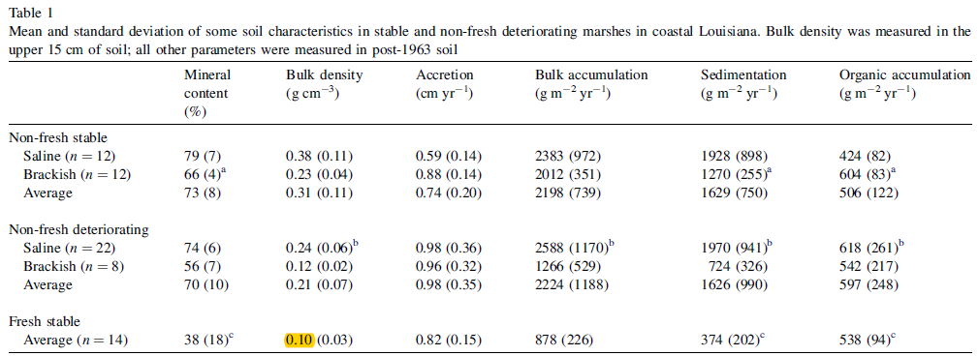

2. Soil C rate data was calculated from Organic accumulation data (Table 2, page 376).

According to the response from Blanca, we found that this paper does not report carbon density directly. We calculated carbon density from OM content and bulk density, but not carbon concentration. To calculate carbon density, their data were entered into a spreadsheet, then processed with SAS code to calculate carbon density. The calculation steps were as follows:

a. Convert organic matter (OM) to organic carbon units.

We used the following equation developed by James Holmquist (in review):

SoilCC=0.074\*(OM/100)\*(OM/100) + 0.421\*(OM/100) - 0.0080, where

SoilCC = C concentration in units of grams C per grams soil

OM = organic matter concentration in units of grams OM per grams soil

b. Convert soil carbon concentration (SoilCC) to carbon density.

SC=SoilCC\*BD, where

SC=Soil carbon density in units of grams carbon per cubic centimeter (g/cm3)

Soil C rate data was calculated as:

SC rate = SC \* accumulation rate\*10000;

